**DATETIME FUNCTIONS SQL QUERIES**

**1.** --elimizde musterilerin oldugu veri tabanindan dogum gunu bugun olanlari cekin

SELECT * FROM LAB01

WHERE DATEPART(MONTH,BIRTHDATE) = DATEPART(MONTH,GETDATE()) AND

DATEPART(DAY,BIRTHDATE) = DATEPART(DAY,GETDATE())

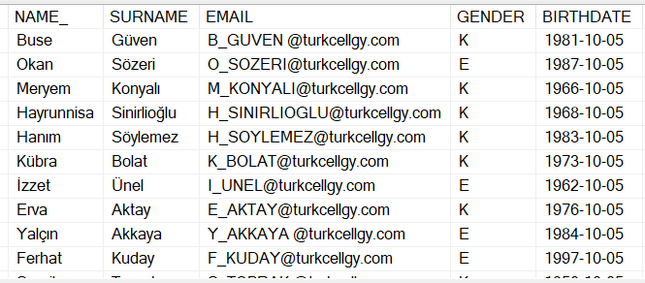

**2.** -- dogum gunu 1 hafta sonra olanlari listeleyiniz.

SELECT * FROM LAB01

WHERE DATEPART(MONTH,BIRTHDATE) = DATEPART(MONTH,DATEADD(WEEK,1,GETDATE())) AND

DATEPART(DAY,BIRTHDATE) = DATEPART(DAY,DATEADD(WEEK,1,GETDATE()))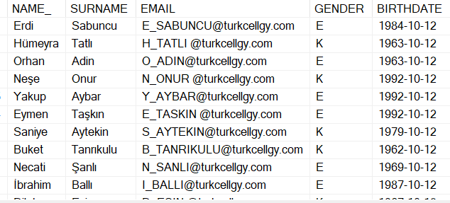

**3.** --dogum yili telefon numarasinda gecen musterileri listeleyiniz.

SELECT ID,NAME_,SURNAME,BIRTHDATE,TELNR1

FROM LAB03

WHERE TELNR1 LIKE '%'+DATENAME(YEAR,BIRTHDATE)+'%'

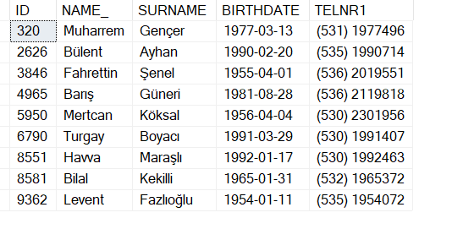

**4.** --elimizde bir market alisveris verisi var. Burada okutulan her urunun okutulma tarihi var.ayrica her islem icin baslama ve bitis tarihi var.

buna gore kasada kesilen her fatura icin musterinin kasada kac saniye bekledigini listeleyiniz.

SELECT DISTINCT INVOICENO, DATE_ START_DATE, INVOICEDATE FINISH_DATE,

DATEDIFF(SECOND,DATE_,INVOICEDATE) WAITING_TIME

FROM LAB04

ORDER BY 1

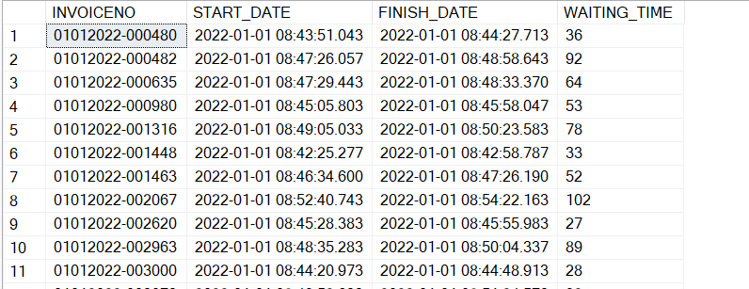

**5.** -- Her bir musterinin kasada ortalama bekleme suresini her bir sehir icin listeleyiniz.

SELECT CITY,

AVG(DATEDIFF(SECOND,DATE_,INVOICEDATE)) AVG_WAITING_TIME

FROM LAB05

GROUP BY CITY

ORDER BY 1

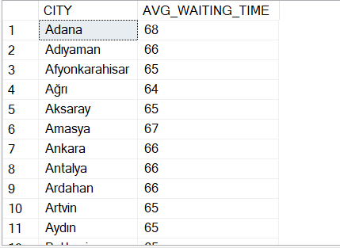

**6.** --Kasada kasiyerlerin performansini olcmek istiyoruz. Bu verilere gore bir kasiyerin bir urunu ortalama kac saniyede okuttugunu sehirlere gore listeleyiniz.SELECT CITY, SUM(DURATION)TOTAL_DURATION,

SUM(TOTAL_AMOUNT)TOTAL_PRODUCT_AMOUNT,

ROUND(SUM(DURATION) / SUM(TOTAL_AMOUNT),2) SPENDING_TIME_FOR_ONE_PRODUCT

FROM

(

SELECT CITY,INVOICENO,MIN(BARCODEDATE)FIRST_BARCODE, MAX(BARCODEDATE) LAST_BARCODE,

DATEDIFF(SECOND,MIN(BARCODEDATE),MAX(BARCODEDATE))DURATION, SUM(AMOUNT)TOTAL_AMOUNT, COUNT(ITEMCODE)ITEM_COUNT

FROM LAB06

GROUP BY CITY,INVOICENO

)T

GROUP BY CITY

ORDER BY SPENDING_TIME_FOR_ONE_PRODUCT

***Output:***

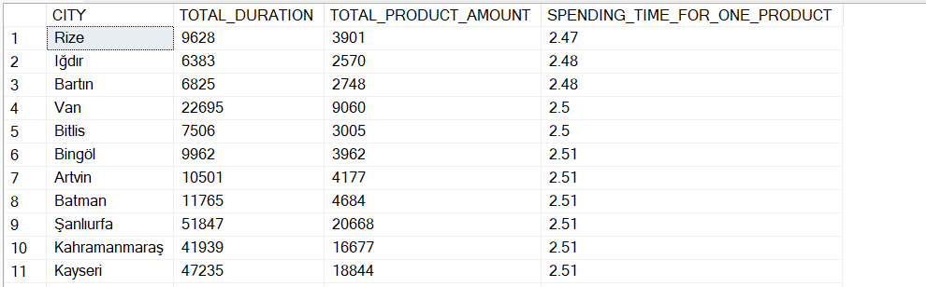

**7..** -- hangi saat ne kadar yorum atildigi bilgisini listeleyiniz

select DATEPART(HOUR,CreationDate)'HOURS', COUNT(Id)COMMENT_NUMBERS from LAB08

GROUP BY DATEPART(HOUR,CreationDate)

ORDER BY 1

***Output***

